Hightower High School Band Booster Organization General Parent Meeting
www.canenationband.com
October 26, 2022
Meeting held via Zoom
Establish Quorum, Call to Order: 7:05pm by L. Bailey
Secretary’s Report: Copies of meeting minutes were emailed to board.
Treasurer’s Report: Beginning Balance as of October 26, 2022: $48,194.68
Income:
Expenses:
Ending Balance as of October 26, 2022:
Amegy Band Balance as of October 26, 2022:
President’s Report:
-Review of Action Items:
-update Cane Nation Website (K. Jerome, L. Bailey, M. Ruggs)
-on Charms update student accounts (K. Jerome)-make sure Jot Form, Charms and PayPal are lining up (please check your charms accounts to make sure there are not any discrepancies)

Fundraisers:
^{Double Good Popcorn}
- ^{Will begin November 1st-5th}
- Will be used towards the Disney Trip to decrease expenses
- Prizes will be available for the top three sellers!
- Band members not attending the Disney Trip are not permitted to participate
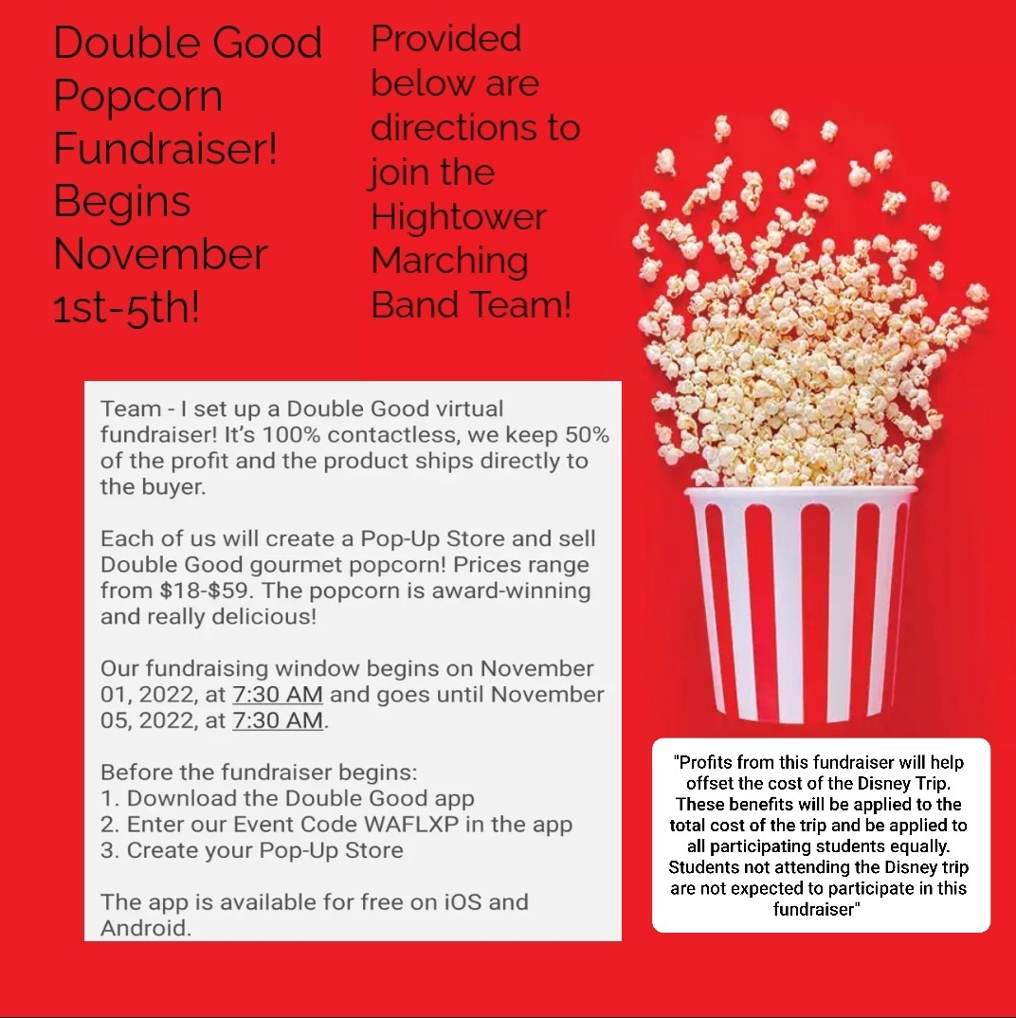
^{Wreaths Across America}
- ^{Approved}
- Will begin towards the end of November
Amazon
- Still ongoing
- Information is provided on the Cane Nation Website
Kroger
- Still ongoing
- Information is provided on the Cane Nation Website

Aim Fundraising
-Approved
-will begin in December
Following Fundraisers maybe added:
- Mattress Fundraiser
- Vertical Raise
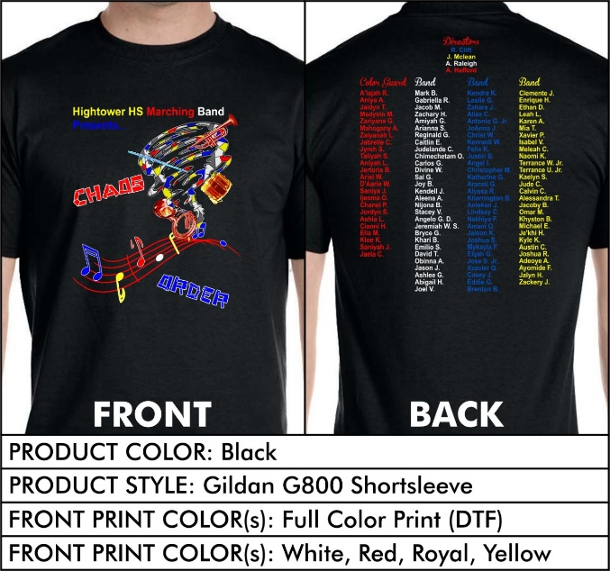
UIL/Show shirt:
- Have been delivered!
- T-shirt design contest winners: Chanel Powell and Araceli Garcia!
- Prizes have been received for contest winners!

Senior Night
- November 3rd
- Have two Parent Volunteers helping with plans and preparation
- Senior signs have been delivered
- Senior banners may be available for purchase depending upon responses from Seniors and Senior parents, only $35 for a 24x36 banner, if you are interested, please email me at canenationband@gmail.com ASAP and please attach a photo of your Senior. Either a Senior picture or Band picture.
- A meal will be provided for the Seniors as well as the Senior’s parents or special guests.
- Parents will be escorting their Senior onto the Football Field for Senior Recognition

Banquet:
- We would like to create a Parent Volunteer Banquet Committee
- Duties: help with finding a venue, help collect and compare venue prices, get prices from the venue for food and decorations
- Once venue, food and decorations are selected Booster will pay for the event
- Dates to consider for having the event: May 12th, 13th, 19^{th,} or 20th

Food Donations: Time to restock our snack supplies!
- Water
- Granola bars
- Chips
- Fruit snacks
- Kool Aid Jammers
- Capri Suns
- Cheez its
- Goldfish

• Other questions, business, and items to handle

Other Officer Reports:

Sponsor/Donation:
- Sienna Plantation Animal Hospital
- Color Guard Donation Amount $1000
- HEB
- Color Guard Donation Amount $250
- The Blackbaud Giving Fund

Disney Trip:
- Payments will begin September 1st, 2022
- Will be setup via PayPal (email with links to setup full payment or payment
arrangements/plan was sent)
- Trip dates approved Friday March 10th-15th
- Cost $1445 (insurance included)
- Booster will provide 4 meals (1 dinner, 2 breakfasts, 1 lunch)
- Currently we have 58 students who are attending
- you may also pay by cash or check
-Will notify parents soon on how to make travel arrangements etc. if they would
like to go on the Disney Trip

Committee Reports:
Upcoming Dates: (playoff schedule will be sent out soon, Region music will be handed out soon, Solo and Ensemble music will be ready before the Winter break)

General Meeting 10/26/2022
Football Game vs Clements 10/27/2022
No School 10/31/2022
All Region Orchestra Winds Audition 11/1/2022
Football Game vs Austin (Senior Night) 11/3/2022
Executive Board Meeting 11/8/2022
Playoffs Window Begins 11/10/2022-11/26/2022
Dreamgirls Rehearsal 11/10/2022
Color Guard Drill Day 11/12/2022
All Region Phase 1 First Night 11/14/2022
Dreamgirls Rehearsal 11/15/2022
All Region Phase 1 Second Night 11/16/2022
Thanksgiving Break 11/21/2022-11/25/2022
Dreamgirls Rehearsal 11/29/2022
General Meeting 11/29/2022
Christmas Concert December 6th
Dreamgirls Production last weekend in January

Principal & Directors Report:
- Updates on our current direction
  - Needs
  - Band member’s schedules are still being adjusted for the members that are still not currently in a band class

Old Business:

New Business:
- Items for Next Meeting
- Please fill out Survey coming soon with information, regarding Block Scheduling

Adjournment: 7:27pm
Minutes taken by L. Bailey
Criminal History Application Link
Forward Approval Email to canenationband@gmail.com

