Congratulations! You are a member of the Hightower High School Band Booster Organization/Club!
General meetings are held in the Band Hall or Zoom every 4th Tuesday of the month. They begin at 6:30pm. However, dates and times may change if there are any major/mandatory scheduling conflicts. At the General meetings we discuss future endeavors, give our input, learn specific information about events and the needs of the band and we discuss/review finances. As a Band Booster member we ask that in some way please give your time and help. The band needs you! The kids need you! The directors need you! Thank you so much for your support!
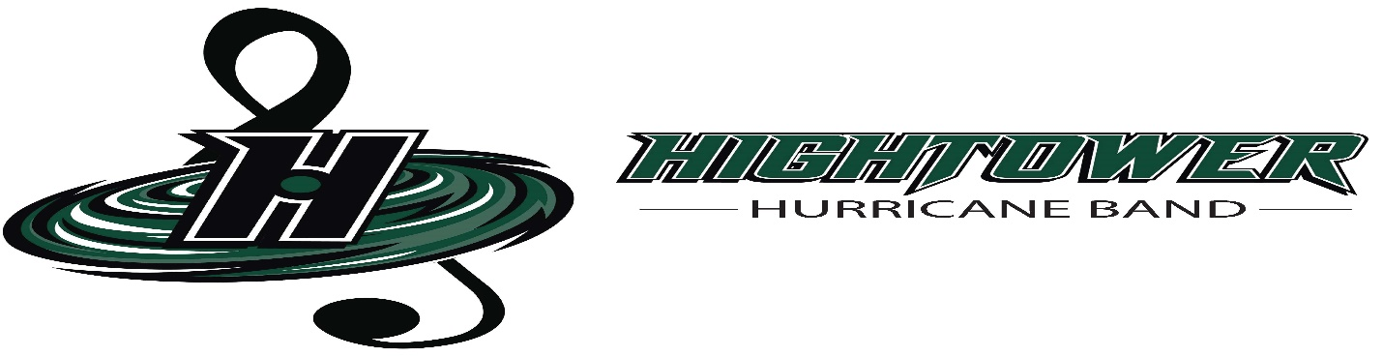

General Meeting Schedule
All meetings begin at 6:30pm
August 7th 2023 (1st Monday of the mth.)
August 22nd 2023
September 26th 2023
October 24th 2023
November 28th 2023
December 13th 2023 (2nd Wednesday of the mth.)
January 23rd 2024
February 27th 2024
March 26th 2024
April 23rd 2024
May 28th 2024

