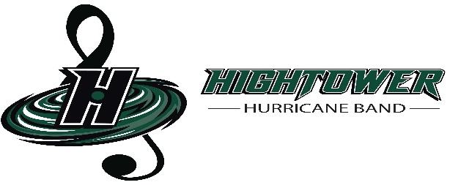
Hightower High School Band Booster Organization General Parent Meeting
www.canenationband.com
April 25, 2023
In Person
Establish Quorum, Call to Order: by L. Bailey at 6:10pm
Secretary’s Report: Copies of meeting minutes were emailed to board.
Treasurer’s Report: Beginning Balance as of April 25, 2023: $14,566.73
Income: $2,880.81
Expenses: $9,431.31
Ending Balance as of April 25, 2023: $14,566.73
Amegy Band Balance as of April 25, 2023:
President’s Report:
- Review of Action Items:
- update Cane Nation Website (last updated April 2023 L. Bailey)
- Charms/update student accounts (K. Jerome-last updated April 2023)

Fundraisers:
Kroger
- Still ongoing
- Information is provided on the Cane Nation Website
http://www.canenationband.com/#/
Vertical Raise
- Vertical Raise began on April 21st, 2023
- This fundraiser is for all Band and Color Guard Members
- Top three sellers will receive a prize!!

Banquet:
- Looking for parent volunteers to help with decorating on the day of the
Banquet. Arrival time will be 3pm.
2. The Banquet will be on Saturday May 20th from 5-9pm
3. Tickets are now on Sale $30
4. Venue: Restoration Life Center

Fire Sale Items:
- Eye of the Storm Hoodies $10
- Color Guard Hoodies $10
- Beanies $5
- Hats/Visors $5
- 2021-2022 Green shirts/black shorts $5

Voting for the 2023-2024 Booster Band Organization!
The positions are: (new elected Executive Board Members)
- President L. Bailey
- Vice President G. Tribble
- 2nd Vice President
- Treasurer M. Guidry
- Assistant Treasurer
- Secretary N. Villagran
- Historian S. Gipson
- Parliamentarian N. Roman
- Color Guard Liaison

Committees you can sign up for the 2023-2024 school year:
- Fundraiser Committee
- Sponsor/Donation Committee
- Pit Crew/Prop Team Committee
- Uniform Committee
- Tailgating/Homecoming Committee
- Banquet Committee
- Nomination Committee
- Budget Committee
- Meal Committee
10.Volunteer Committee

• Other questions, business, and items to handle

Other Officer Reports:

Sponsor/Donation:
- Sienna Plantation Animal Hospital
- 3 Color Guard Donations
- HEB
- The Blackbaud Giving Fund
- Raising Cane

Committee Reports:
Upcoming Dates:
Leadership interest meeting 4/24/2023
General Parent Meeting 4/25/2023
Mr. Lipman Clinic 4/25/2023
Color Guard Spring Show 4/27/2023 6:30pm
Lake Olympia 30th Anniversary Parade 4/29/2023
Leadership Applications due 5/1/2023
LOMS Concert 5/3/2023
Night of the Drums Percussion Concert 5/4/2023
Mr. Lipman Clinic 5/8/2023
Executive Board Meeting 5/9/2023
Spring Band Concert Dress Rehearsal 5/10/2023
Spring Band Concert 5/11/2023
Band Registration Due 5/15/2023
Leadership Camp 5/15-5/19 2023
Band Banquet 5/20/2023
General Parent Meeting 5/23/2023
Hightower Graduation 5/27/23 8pm

Principal & Directors Report:
- Updates on our current direction
  - Needs

Old Business:
• Deadline for past due Band and Color Guard fees May 1st!

New Business:
- Items for Next Meeting
- Band Camp for the 2023-2024 school year: Begins on July 17th

Adjournment: at 6:55pm
Criminal History Application Link
Forward Approval Email to canenationband@gmail.com

